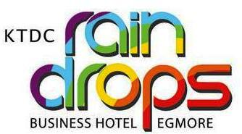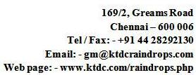

KTDC/RD/Qtn/538/2022-23 Dated: 07/01/2023

KTDC Raindrops invites **sealed** quotations from suppliers/firms for the below mentioned work on an annual contract basis for one year.

1. AMC of Gas Burners 7 Equipment’s
2. Renewal Fire license and NCAMC of fire fighting equipment’s.

For details & tender forms please contact the office of the Manager with payment of Rs.200+GSTduring office hours from 10.00 AM to 5 PM from 12/01/2023 to 27/01/2023.

**For details: Mob: 9445293332**

MANAGER